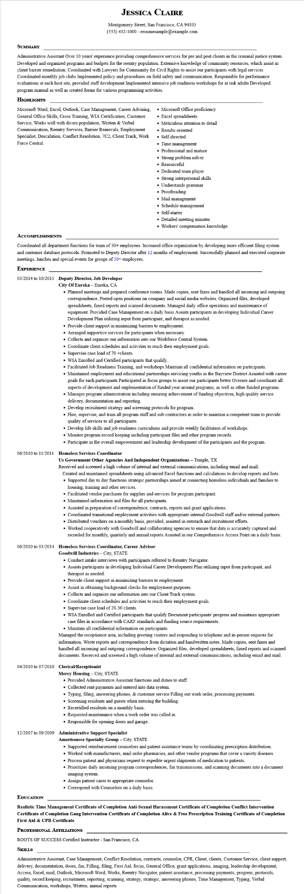
JESSICA CLAIRE
Montgomery Street, San Francisco, CA 94105
(555) 432-1000 - resumesample@example.com
SUMMARY
Administrative Assistant Over 10 years' experience providing comprehensive services for pre and post clients in the criminal justice system. Developed and organized programs and budgets for the reentry population. Extensive knowledge of community resources, which assist in client barrier remediation. Coordinated with Lawyers for Community for Civil Rights to assist our participants with legal services Coordinated monthly job clubs Implemented policy and procedures on field safety and communication. Responsible for performance evaluations at each host site, provided staff development Implemented intensive job readiness workshops for at risk adults Developed program manual as well as created forms for various programming activities.
HIGHLIGHTS
Microsoft Word, Excel, Outlook, Case Management, Career Advising, General Office Skills, Cross Training, WIA Certification, Customer Service, Works well with divers population, Written & Verbal Communication, Reentry Services, Barrier Removals, Employment Specialist, Descalation, Conflict Resolution, 7C2, Client Track, Work Force Central.
ACCOMPLISHMENTS
• Microsoft Office proficiency
• Excel spreadsheets
• Meticulous attention to detail
• Results-oriented
• Self-directed
• Time management
• Professional and mature
• Strong problem solver
• Resourceful
• Dedicated team player
•
Strong interpersonal skills
Understands grammar
• Proofreading
• Mail management
• Schedule management
• Self-starter
• Detailed meeting minutes
• Workers' compensation knowledge
Coordinated all department functions for team of 50+ employees. Increased office organization by developing more efficient filing system and customer database protocols. Promoted to Deputy Director after 12 months of employment. Successfully planned and executed corporate meetings, lunches and special events for groups of 50+ employees.
EXPERIENCE
03/2014 to 10/2015 Deputy Director, Job Developer
City Of Eureka - Eureka, CA
• Planned meetings and prepared conference rooms. Made copies, sent faxes and handled all incoming and outgoing correspondence. Posted open positions on company and social media websites. Organized files, developed spreadsheets, faxed reports and scanned documents. Managed daily office operations and maintenance of equipment. Provided Case Management on a daily basis Assists participants in developing Individual Career Development Plan utilizing input from participant, and therapist as needed.
• Provide client support in minimizing barriers to employment.
• Arranged supportive services for participants when necessary.
• Collects and organize our information into our Workforce Central System.
• Coordinate client schedules and activities to reach their employment goals. Supervise case load of 70 +clients.
• WIA Enrolled and Certified participants that qualify.
• Facilitated Job Readiness Training, and workshops Maintain all confidential information on participants.
• Maintained employment and educational partnerships servicing youths in the Bayview District Assisted with career goals for each participants Participated in focus groups to assist our participants better Oversee and coordinate all aspects of development and implementation of funded year-around programs, as well as other funded programs. • Manages program administration including ensuring achievement of funding objectives, high quality service delivery, documentation and reporting.
• Develop recruitment strategy and screening protocols for program.
• Hire, supervise, and train all program staff and sub-contractors in order to maintain a competent team to provide quality of services to all participants.
• Develop life skills and job readiness curriculums and provide weekly facilitation of workshops.
• Monitor program record keeping including participant files and other program records.
• Participate in the overall empowerment and leadership development of the participants and the program.
06/2010 to 11/2011 Homeless Services Coordinator
Us Government Other Agencies And Independent Organizations – Temple, TX
Received and screened a high volume of internal and external communications, including email and mail. Created and maintained spreadsheets using advanced Excel functions and calculations to develop reports and lists. • Supported day to day functions strategic partnerships aimed at connecting homeless individuals and families to housing, training and other services.
• Facilitated vendor purchases for supplies and services for program participant.
• Maintained information and files for all participants.
• Assisted in preparation of correspondence, contracts, reports and grant applications.
• Coordinated transitional employment activities with appropriate internal Goodwill staff and/or external partners.
• Distributed vouchers on a monthly basis, provided, assisted in outreach and recruitment efforts.
• Worked cooperatively with Goodwill and collaborating agencies to ensure that data is accurately captured and recorded for monthly, quarterly and annual reports Assisted in our Comprehensive Access Point on a daily basis.
06/2010 to 03/2014 Homeless Services Coordinator, Career Advisor
Goodwill Industries - City, STATE
• Conduct intake interviews with participants referred to Reentry Navigator.
• Assists participants in developing Individual Career Development Plan utilizing input from participant, and therapist as needed.
• Provide client support in minimizing barriers to employment.
• Assist in obtaining background checks for employment purposes.
• Collects and organize our information into our Client Track system.
• Coordinate client schedules and activities to reach their employment goals.
• Supervise case load of 20-30 clients.
• WIA Enrolled and Certified participants that qualify Document participants' progress and maintains appropriate case files in accordance with CARF standards and funding source requirements.
• Maintain all confidential information on participants.
Managed the receptionist area, including greeting visitors and responding to telephone and in-person requests for information. Wrote reports and correspondence from dictation and handwritten notes. Made copies, sent faxes and handled all incoming and outgoing correspondence. Organized files, developed spreadsheets, faxed reports and scanned documents. Received and screened a high volume of internal and external communications, including email and mail.
04/2010 to 07/2010 Clerical/Receptionist
Mercy Housing - City, STATE
• Provided Administrative Assistant functions and duties to staff.
• Collected rent payments and entered into data system.
• Typing, filing, answering phones, & customer service Filling out work order, processing payments.
• Screening residents and guests when entering the building.
• Recertified residents on a monthly basis.
• Requested maintenance when a work order was called in.
• Responsible for opening doors and garage.
12/2007 to 09/2009 Administrative Support Specialist
Amerisource Specialty Group - City, STATE
• Supported reimbursement counselors and patient assistance teams by coordinating prescription distribution.
• Worked with manufacturers, mail order pharmacies, and other vendor programs that cover a variety diseases.
• Process patient and physicians request to expedite urgent shipments of medication to patients.
• Prioritizes daily incoming program correspondences, fax transmissions, and scanning documents into a document imaging system.
• Assign patient cases to appropriate counselor.
EDUCATION
• Correspond with Counselors on a daily basis.
Realistic Time Management Certificate of Completion Anti-Sexual Harassment Certificate of Completion Conflict Intervention Certificate of Completion Gang Intervention Certificate of Completion Alive & Free Prescription Training Certificate of Completion First Aid & CPR Certificate
PROFESSIONAL AFFILIATIONS
ROOTS OF SUCCESS Certified Instructor - San Francisco, CA
SKILLS
Administrative Assistant, Case Management, Conflict Resolution, contracts, counselor, CPR, Client, clients, Customer Service, client support, delivery, documentation, doors, fax, Filling, filing, First Aid, focus, General Office, grant applications, imaging, leadership development, Access, Excel, mail, Outlook, Microsoft Word, Works, Reentry Navigator, patient assistance, processing payments, progress, protocols, quality, record keeping, recruitment, reporting, scanning, strategy, strategic, answering phones, Time Management, Typing, Verbal Communication, workshops, Written, annual reports

